This is the Final part of cracking detection. The first one I sent you is a TensorFlow implementation of the Deep Learning-Based Crack Detection Using Convolutional Neural Networks. The second part, I first do data cleaning by SAS. Thus, I cleaned the data to a clear version and use it feed the machine leaning model on AWS ReKognition.

Details,

Data preparing and cleaning:

I open the .mdb file in the Linux environment and I export it to CSV files. Feeding the deep learning model by CSV files. Use SAS university version software to do data cleaning, which is sort by category and sort by time.

The crack analysis is triggered by the ProcessImage Lambda function in Scala. The processImage function only processes one image at a time. It performs the following tasks:

1. Download images from Amazon S3

2. Call Amazon Rekognition to detect cracks

3. Use the bounding box provided by the detect operation to crop the crack from the image

4. Try to identify the crack by searching for each crack information in the specified set of cracks

5. Add the results of the crack identification

6. Create a report record

7. Upload report history to Amazon S3

Among them, the cascade crack detection step calls the ProcessImage Lambda function asynchronously for each screen capture image in parallel. Each ProcessImage function calls Amazon Rekognition to detect its own crack. The parallel mapping function of the ProcessImage function is called for each image frame.

The important part of AWS Rekognition:

A, Behind the scenes

how it works and a few general principles.

When you need to make use of other pre-built programs such as FFmpeg, you can run another program or start a new process in Lambda.

B, Dependency Tree:

The dependency trees with trace data that I can use to drill into specific services or issues. This provides a view of connections between services in your application and aggregated data for each service, including average latency and failure rates.

C, Amazon Rekognition API call

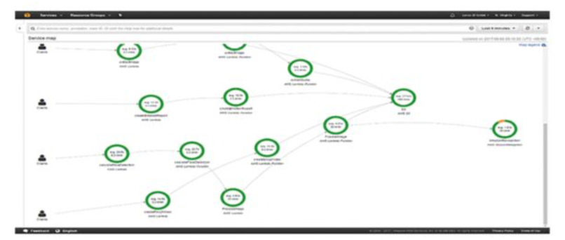

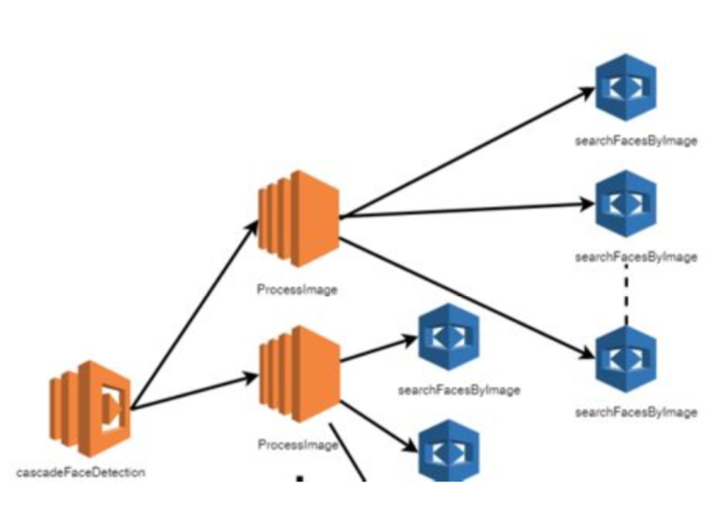

D,Equations

Latency is the amount of time between the start of a request and when it completes.

E, Lambda cascading timeline

Each time I detected a crack, I set the lambda parameter to the corresponding time. Find the depth of the corresponding crack in the dataset and display the depth, time, and crack type in the video. I have attached a video example. I think when we next meet, I will explain it to you in detail and discuss the specific content of the next project.

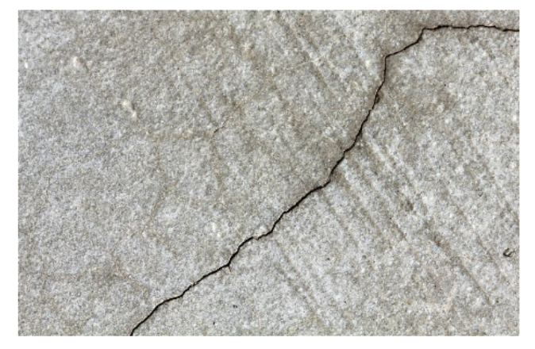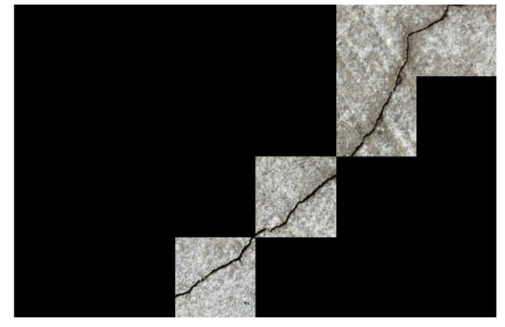

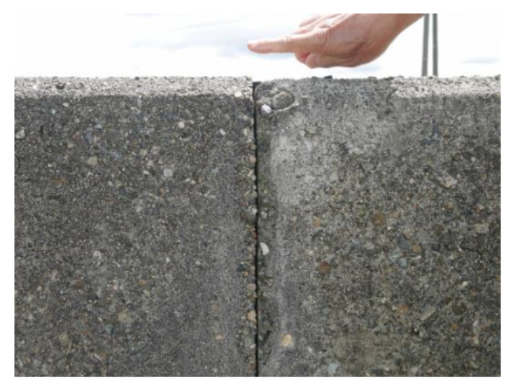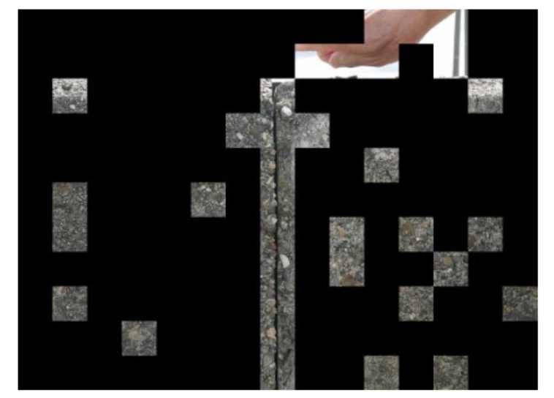

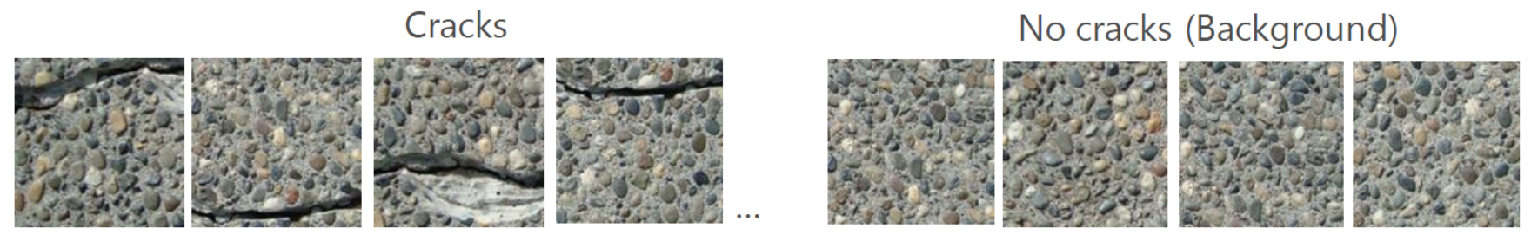

**sample video:**

**When the crack height is too high, corresponding to different height values in a period, I chose to take the highest point.**

